**2.1 INTRODUCTION**

A **Sensor** is a [converter](http://en.wikipedia.org/wiki/Energy_conversion) that measures a [physical quantity](http://en.wikipedia.org/wiki/Physical_quantity) and converts it into a signal which can be read by an observer or by an (today mostly [electronic](http://en.wikipedia.org/wiki/Electronics)) instrument. For example, a [mercury-in-glass thermometer](http://en.wikipedia.org/wiki/Mercury-in-glass_thermometer) converts the measured temperature into expansion and contraction of a liquid which can be read on a calibrated glass tube. A [thermocouple](http://en.wikipedia.org/wiki/Thermocouple) converts temperature to an output voltage which can be read by a [voltmeter](http://en.wikipedia.org/wiki/Voltmeter). For accuracy, most sensors are [calibrated](http://en.wikipedia.org/wiki/Calibration) against known [standards](http://en.wikipedia.org/wiki/Standard_(metrology)). Sensors are used in everyday objects such as touch-sensitive elevator buttons ([tactile sensor](http://en.wikipedia.org/wiki/Tactile_sensor)) and lamps which dim or brighten by touching the base. There are also innumerable applications for sensors of which most people are never aware. Applications include cars, machines, aerospace, medicine, manufacturing and robotics.

**2.2 PIR SENSOR**

The PIR (Passive Infra-Red) Sensor is a pyroelectric device that detects motion by measuring changes in the infrared levels emitted by surrounding objects. This motion can be detected by checking for a high signal on a single I/O pin.

**2.2.1 Theory of Operation**

Pyroelectric devices, such as the PIR sensor, have elements made of a crystalline material that generates an electric charge when exposed to infrared radiation. The changes in the amount of infrared striking the element change the voltages generated, which are measured by an on-board amplifier. The device contains a special filter called a Fresnel lens, which focuses the infrared signals onto the element. As the ambient infrared signals change rapidly, the on-board amplifier trips the output to indicate motion.

**2.2.2 Features**

* Single bit output
* Small size makes it easy to conceal
* Compatible with all Parallax microcontrollers
* 3.3V & 5V operation with <100uA current draw

**2.2.3 Calibration**

The PIR Sensor requires a ‘warm-up’ time in order to function properly. This is due to the settling time involved in ‘learning’ its environment. This could be anywhere from 10-60 seconds. During this time there should be as little motion as possible in the sensors field of view.

**2.2.4 Sensitivity**

The PIR Sensor has a range of approximately 20 feet. This can vary with environmental conditions. The sensor is designed to adjust to slowly changing conditions that would happen normally as the day progresses and the environmental conditions change, but responds by making its output high when sudden changes occur, such as when there is motion.

**2.2.5 Pin Definitions and Ratings**

**Pin Name Function**

- GND Connects to Ground or Vss

+ V+ Connects to Vdd (3.3V to 5V) @~100uA

OUT Output Connects to an I/O pin set to INPUT mode

(or transistor/MOSFET)

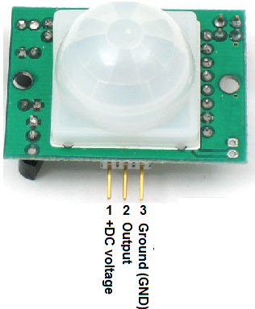

**Figure :** PIR Sensor

**2.2.6 How PIRs Work**

PIR sensors are more complicated than many of the other sensors because there are multiple variables that affect the sensors input and output. The PIR sensor itself has two slots in it, each slot is made of a special material that is sensitive to IR. The lens used here is not really doing much and so we see that the two slots can 'see' out past some distance (basically the sensitivity of the sensor). When the sensor is idle, both slots detect the same amount of IR, the ambient amount radiated from the room or walls or outdoors. When a warm body like a human or animal passes by, it first intercepts one half of the PIR sensor, which causes a positive differential change between the two halves. When the warm body leaves the sensing area, the reverse happens, whereby the sensor generates a negative differential change. These change pulses are what is detected.

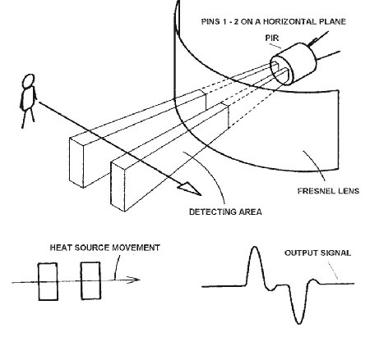

**Figure :** Working of PIR Sensor

**2.3 CONCLUSION**

PIR sensor is a good choice for detecting the presence of any human body or other type of motion in an observed area. It have better sensitivity and provide a single bit output. Due to these reasons it really suits to our project.

balanced sensors.